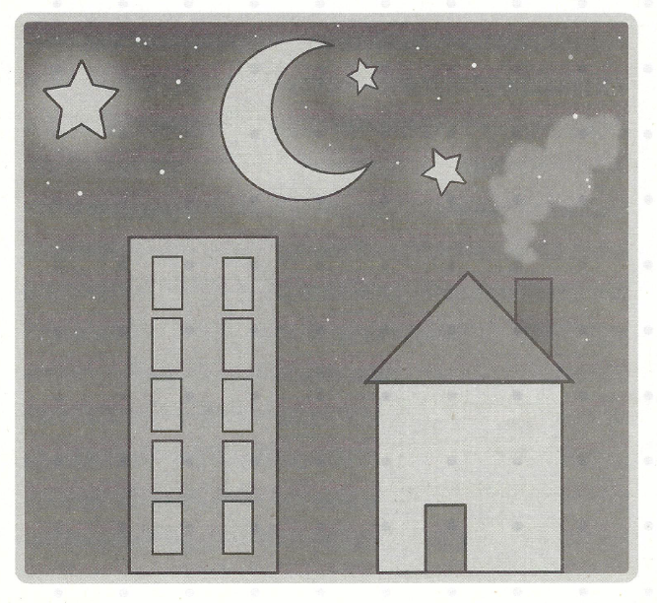
Polygons are plane figures with at least three straight sides and angles or vertices (no curves).
What polygons do you see in the picture above?
____________________________________________________________________________________________________________________
How many quadrilaterals do you see?
____________________________________________________________________________________________________________________

